1. Sign up

Frame function: This frame used to create account when user has not account

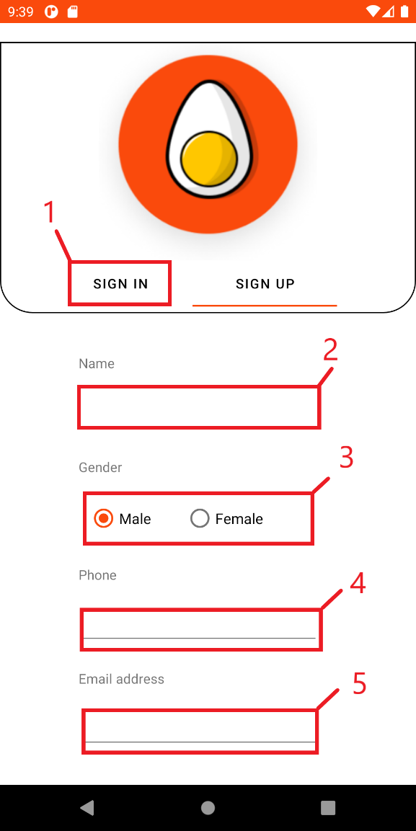

|  |  |  |
| --- | --- | --- |
| **No.** | **Component** | **Function** |
| 1 | Button Sign in | Back to sign in screen |
| 2 | Text name | Input name |
| 3 | Gender | Input gender |
| 4 | Phone | Input phone |
| 5 | Email | Input email |

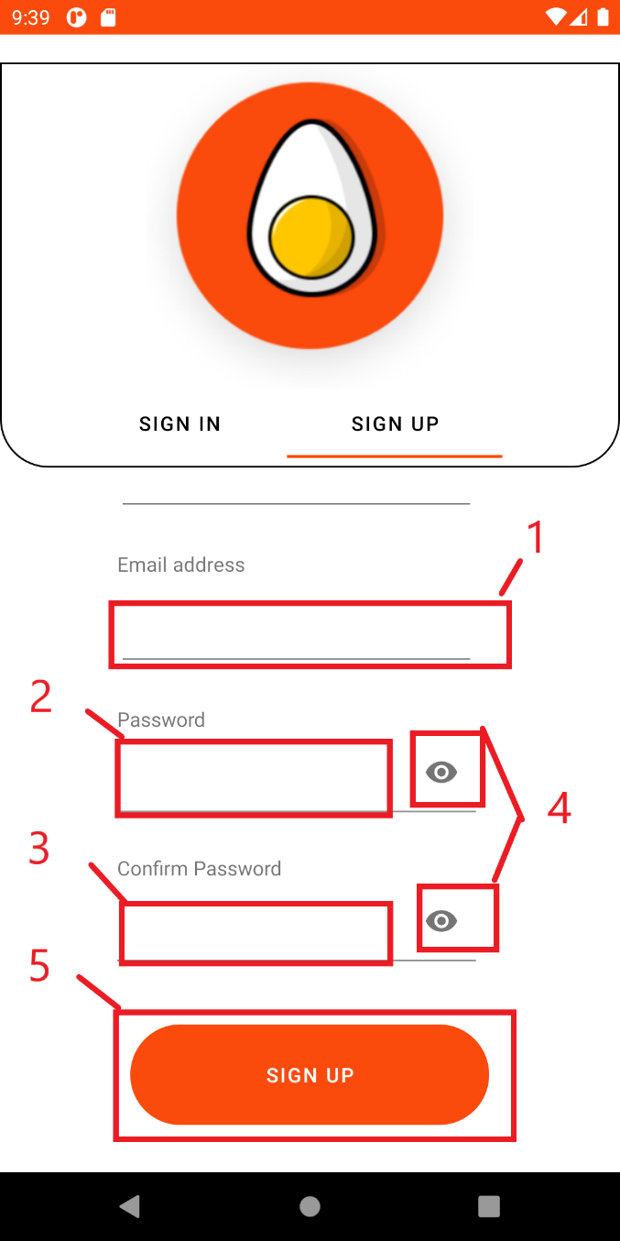

|  |  |  |
| --- | --- | --- |
| **No.** | **Component** | **Function** |
| 1 | Emal address | Input email address |
| 2 | Password | Input password |
| 3 | Confirm password | Input confrm password |
| 4 | See password | Click to see your password |
| 5 | Button sign up | Click to sign up |

1. Staff home page

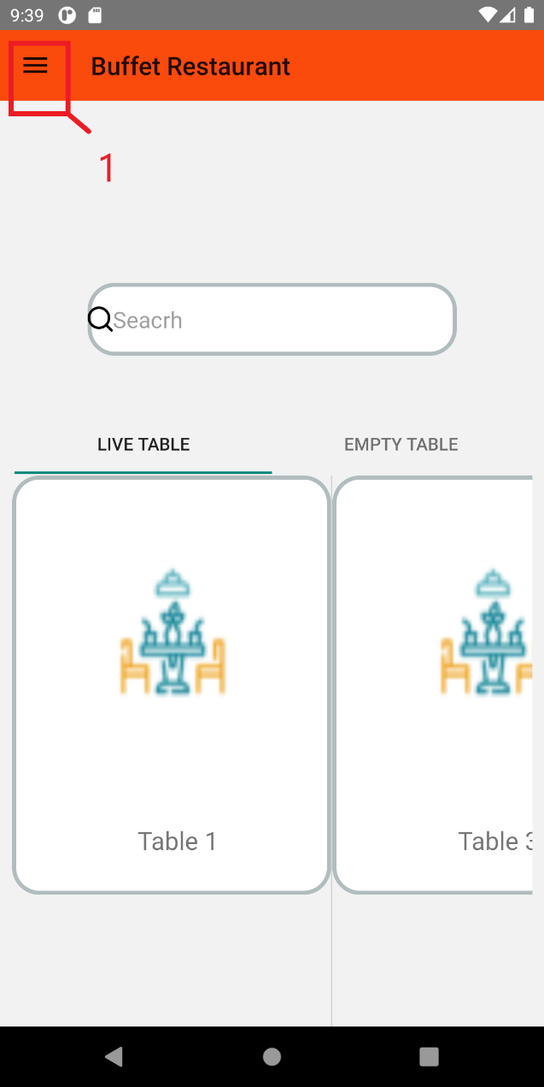Frame function: This frame used to display live table and empty table on the screen for staff

|  |  |  |
| --- | --- | --- |
| **No.** | **Component** | **Function** |
| 1 | Menu button | Click to view more works |

1. View work menu

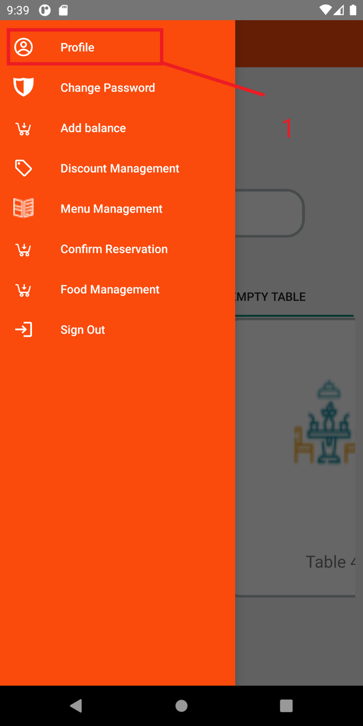Frame function: This frame used to see more works of staff

|  |  |  |
| --- | --- | --- |
| **No.** | **Component** | **Function** |
| 1 | Profile button | Click to view staff’s profile |

1. Staff profile

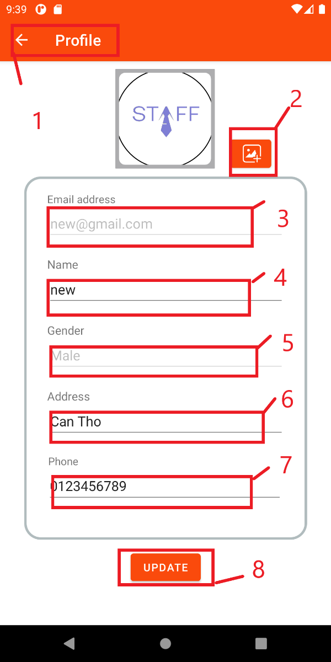Frame function: This frame used to see and update staff’s profile

|  |  |  |
| --- | --- | --- |
| **No.** | **Component** | **Function** |
| 1 | Back button | Click to comeback home page |
| 2 | Update image button | Click to pick image in library |
| 3 | Email address | Input email address |
| 4 | Name | Input name |
| 5 | Gender | Input gender |
| 6 | Address | Input address |
| 7 | Phone | Input phone |
| 8 | Update button | Click to update new profile |

1. View more works

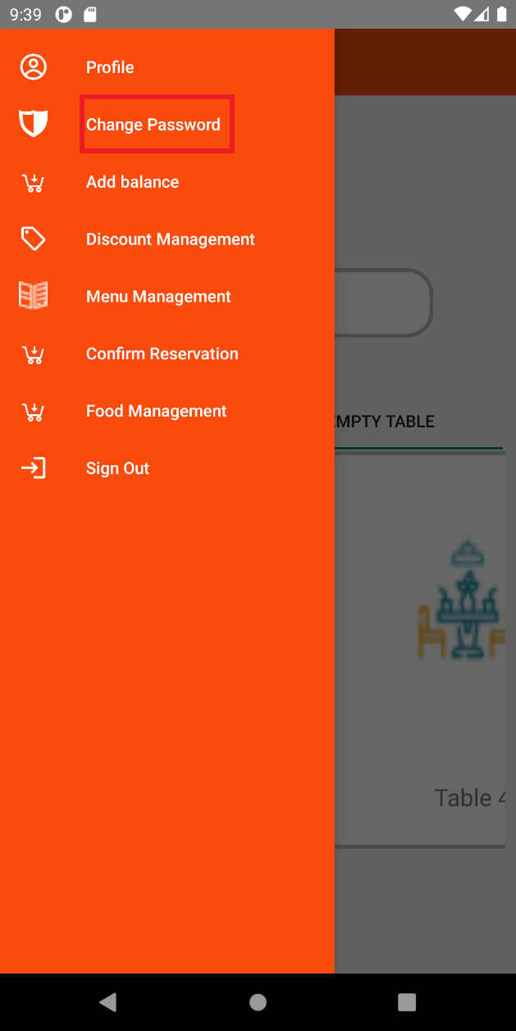

|  |  |  |
| --- | --- | --- |
| **No.** | **Component** | **Function** |
| 1 | Change password button | Click to change password |

1. Change password

Frame function: This frame used to change staff’s password

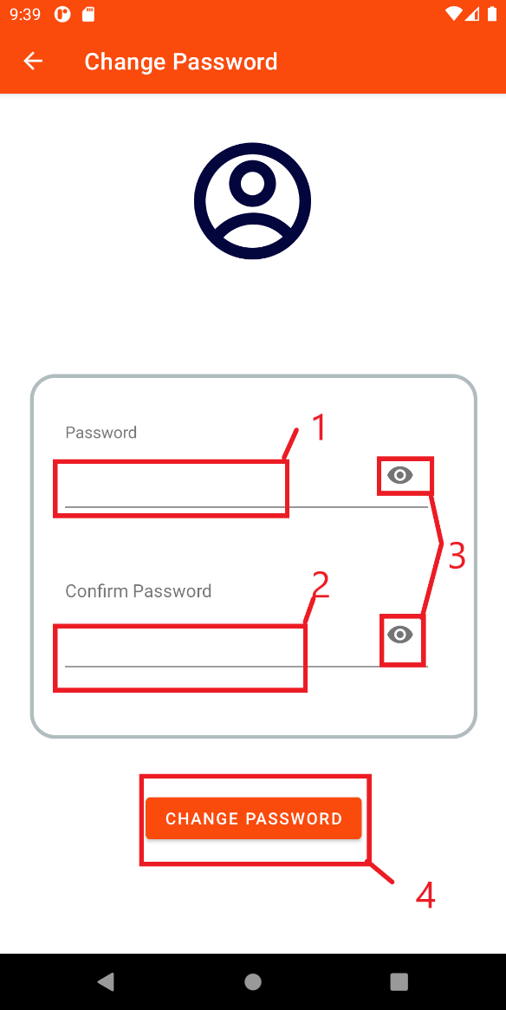

|  |  |  |
| --- | --- | --- |
| **No.** | **Component** | **Function** |
| 1 | Password | Input password |
| 2 | Confirm password | Input confirm password |
| 3 | See password | Click to see password |
| 4 | Change button | Click to change staff’s password |

1. Add balance

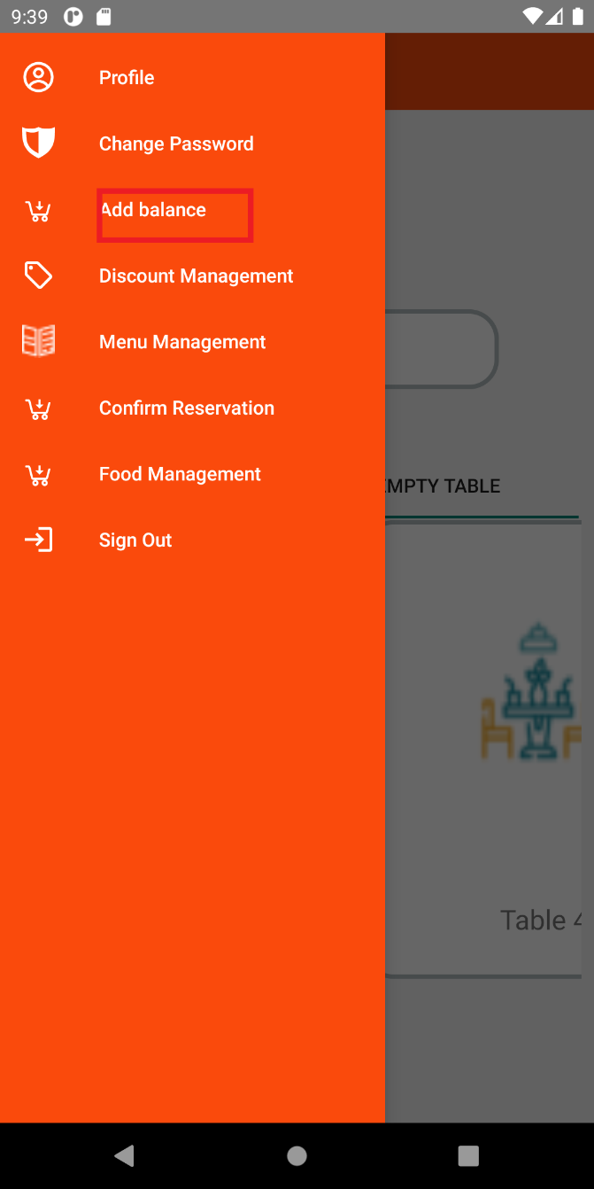Frame function: This frame used to add balance for customer

|  |  |  |
| --- | --- | --- |
| **No.** | **Component** | **Function** |
|  | Add balance button | Click to go to add balance frame |

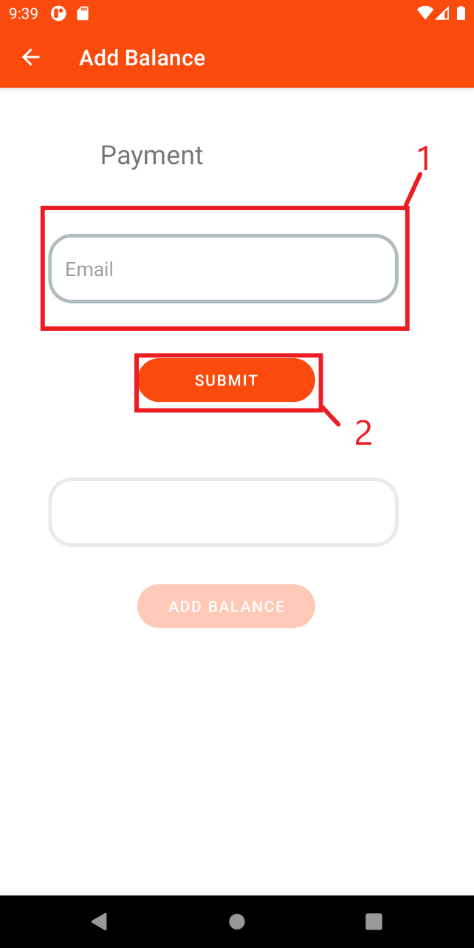

|  |  |  |
| --- | --- | --- |
| **No.** | **Component** | **Function** |
| 1 | Email | Input customer’s email to ad balance |
| 2 | Submit button | Click to check that email is valid or not |

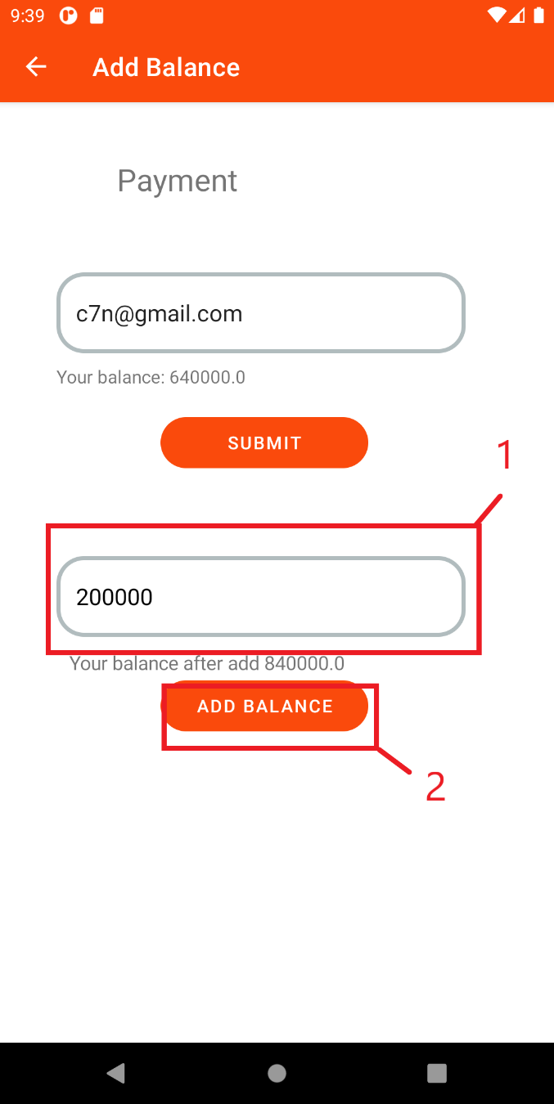

|  |  |  |
| --- | --- | --- |
| **No.** | **Component** | **Function** |
| 1 | Balance | If email is valid, staff can input balance |
| 2 | Add balance button | Click to add balance for customer |

1. Discount manage

Frame function: This function used to manage discount

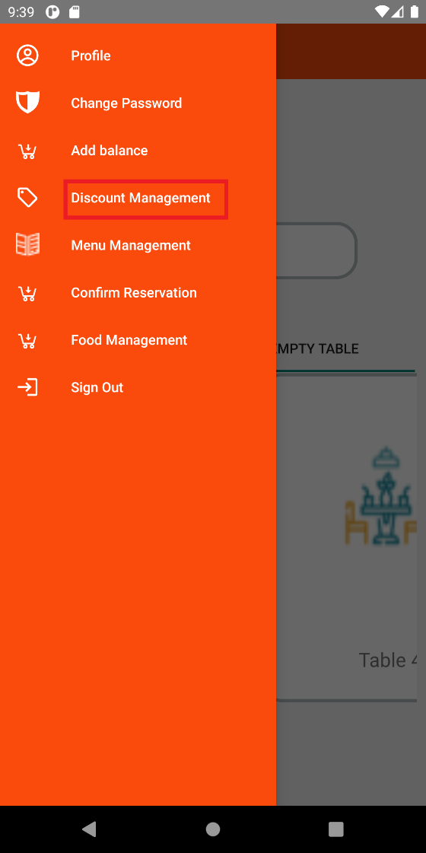

|  |  |  |
| --- | --- | --- |
| **No.** | **Component** | **Function** |
|  | Discount mangement button | Click to go to Discount mangement frame |

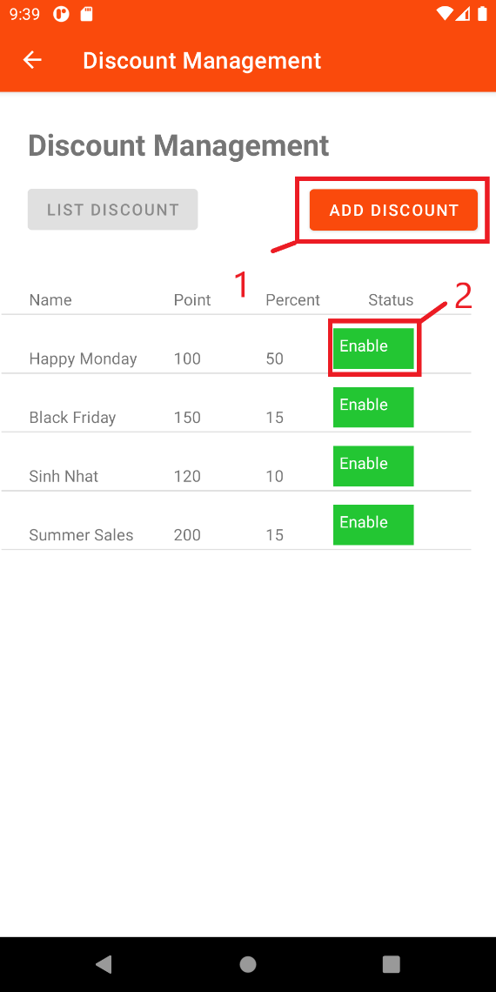View list discount

|  |  |  |
| --- | --- | --- |
| **No.** | **Component** | **Function** |
| 1 | Add discount button | Click to add new discount |
| 2 | Enable button | Click to update that discount |

If user click enable button, user will go to update discount frame

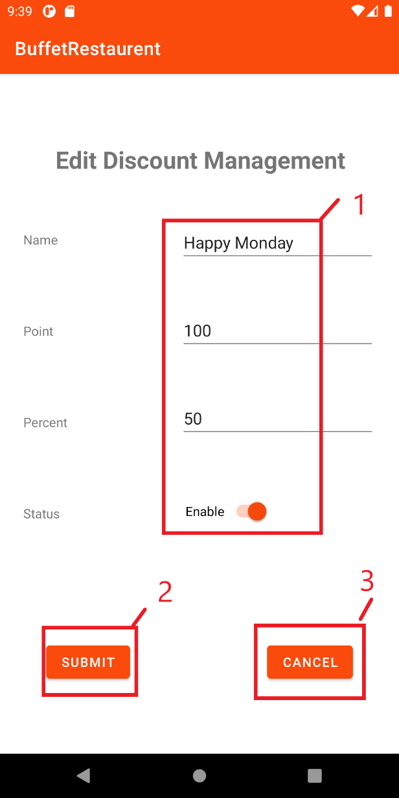

|  |  |  |
| --- | --- | --- |
| **No.** | **Component** | **Function** |
| 1 | Fields | Input all fields need to update |
| 2 | Submit button | Click to update that discount and back to view list discount |
| 3 | Cancel button | Click to back to view list discount |

If user click add discount button, go to add discount frame

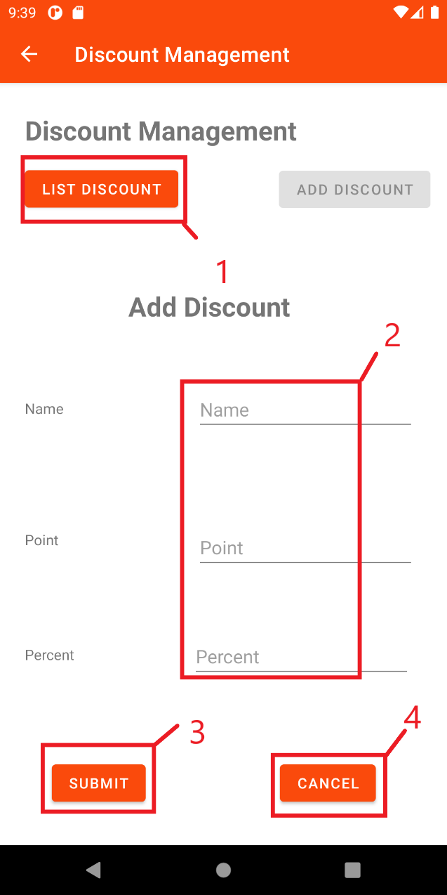

|  |  |  |
| --- | --- | --- |
| **No.** | **Component** | **Function** |
| 1 | List discount button | Click to go back to view list discount |
| 2 | Fields | Input all fields need to update |
| 3 | Submit button | Click to update that discount and back to view list discount |
| 4 | Cancel button | Click to back to view list discount |